GRADE NINE CHRISTIAN EDUCATION
Midterm Study Guide

PART A: Old Testament / New Testament connections

Books of the Bible (review from CE 8): You do not need to be able to recall every single book of the Bible. You will, however, be asked to identify a book as Old Testament or New Testament.

Total number of books in the Bible: _____
How many books in the Old Testament? _____
How many are in the New Testament? _____

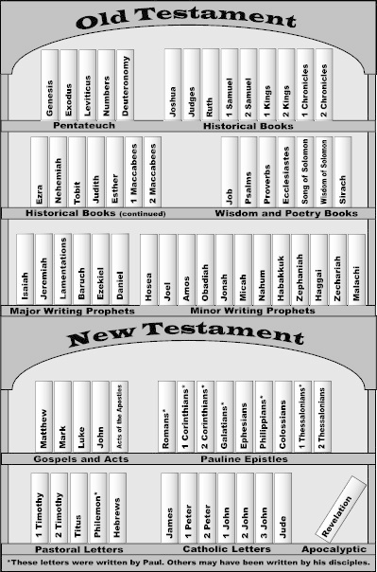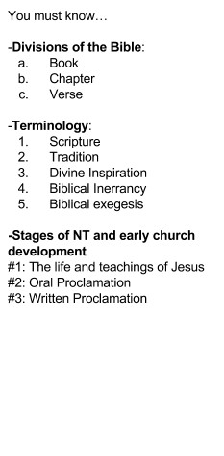
Define:
- Salvation History:
- Monotheism:
- Polytheism:
- Covenant:

Patriarchs:
#1:

#2:

#3:

Salvation History: Please revisit handouts attached to your Salvation History Storyboard Assignment!

Biblical Figures | Description of Covenant | Covenant Sign
Adam and Eve
Noah
Abraham
Moses
David
Jesus

Part B: The Liturgical Year: Please have a look at my prezi again!
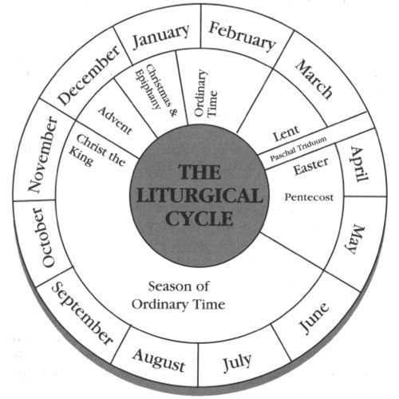
You must know…
- The colours for each season. If you wish, you can colour the diagram above using the appropriate colours.

- The event that marks the end of a liturgical year ______________________

- The first season of the liturgical year is __________________________

- The longest season of the liturgical year is ________________________

- The significance of Pentecost _______________________________

- The events in the Paschal Triduum: _____________________________________________________________________

- The Lenten Season begins on _______________________________

- The Feast of the Epiphany celebrates ________________________________

Part C: The Socio-Political World of Jesus

Provinces & Geography of the Holy Land
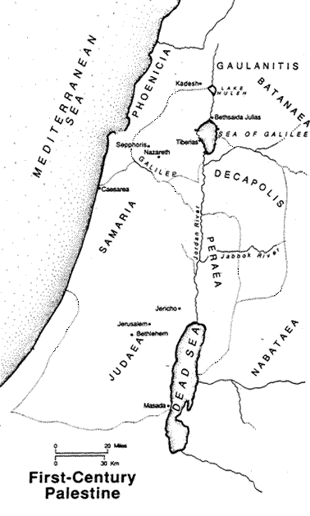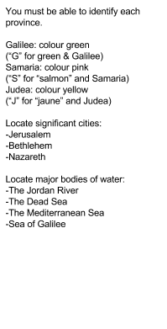

Province | Significant Locations | Characteristics of People in this Region
Galilee
Samaria
Judea

Social Groups in Judaism

Social Group | Characteristics | Connection to Jesus
Great Majority

Sadducees

Pharisees

Essenes

Scribes

Zealots

- What sort of Messiah did most Jews expect?

- Describe the relationship that Jesus had with the Pharisees and Sadducees. Refer to the handout “Jesus and the Law.” What sort of law did Jesus follow? How about the Pharisees? Provide examples from the Bible.

Other Philosophical/Religious Movements: You must be able to recognize/ describe each of these.

Movement | Description
Cynicism

Epicureanism

Hellenism

Astrology

Mystery Cult

Stoicism

Polytheism
Pax Romana

Gentile Presence of the Holy Land:

Explain how Greek and Roman influences shaped the socio-political world in which Jesus lived. How did these Gentile influences help with the spread of Christianity?

Greek Influence | Roman Influence

Part D: The Infancy Narratives : What do we learn about the early life of Christ and the circumstances surrounding his birth in each?

Matthew | Luke

Scripture Reflection: Taken directly from the exam! Please do the readings and reflections during your exam preparation!

From the following three passages from the Infancy Narratives, choose one and write a three-paragraph reflection as follows:
a) A summary of the literal meaning of the passage (about 4 to 5 sentences)
b) The deeper spiritual meaning of the passage (about 4 to 5 sentences)
c) A personal application of the passage to your life (about 4 to 5 sentences)

Passages to choose from:
1. Lk 1:26-38
2. Mt 1:18-25
3. Mt 2:1-12

Development of the Gospels: (refer to pg. 54-55 in your textbook)

 | Matthew | Mark | Luke | John
Who was he?
date written
audience
Image of Jesus
Genealogy
Theological Themes
Symbol

