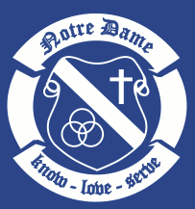

Humanities 8
English | Social Studies | Christian Education

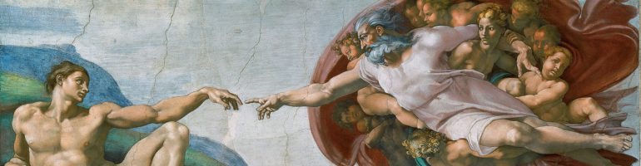

Course Outline 2017 - 2018

Welcome to Humanities 8!
Humanities is a unique course that blends English, Social Studies, and Christian Education into one learning experience for our Grade 8s.

In Humanities, we strive to educate the whole child. Our goal is to help students develop socially, intellectually, and spiritually so they grow into individuals who have confidence, values, and respect for others.
In alignment with the NEW BC curriculum, we will use the year along with our skills and knowledge to develop core and curricular competencies. In Humanities, students will engage in deeper, life-long learning to develop their communication, creative/critical thinking, and personal/social skills.

Mark Breakdown
Because Humanities is a unique blend of English Language Arts, Social Studies, and Christian Education, the final mark is calculated based on skill development in the following areas:
5% Independent Reading
15% Literary Analysis
5% Writing Process
5% Events of Significance
5% Geography
10% Oral Language
10% Creative and Reflective Writing
15% Formal Writing
20% Inquiry/Research
5% Biblical/Historical Figures
5% Citizenship
Total 100%
In order to successfully pass Humanities 8, students must not have an incomplete in any skill development.

School Supplies
- Paper: blank and lined
- Prayer Journal
- Pens (black, blue, red, coloured)
- Whiteout
- Pencils
- Erasers
- Pencil Crayons and/or markers
- Sharpeners
- Sticky Notes (various sizes)
- Silent Reading Novel
- Ruler (12 inches; 30 cm)
- 1.5" Binder
- Dividers (12)
- ​Project Supplies (as they arise
- Highlighters
- Reinforcements (recommended)

Cell Phones, Technology, and Personal Devices
Cell phones will be collected at the beginning of class and returned before dismissal.
The use of all cell phones, technologies, and personal devices is at the sole discretion of the teacher. There is a progressive model of consequences for those students who are found using technologies inappropriately during class time.

Citizenship and Community Service
All students at Notre Dame are required to complete 20 hours of community service. Please refer to the CE Service Hours policy and hours report for more details.

Office Hours and After School Support
I will be available for help and questions after school most days until 4:00pm in room 211. Please send me an email to confirm availability and meeting location.
After School Club runs Monday to Thursday from 3:00-4:00pm in room 204. Teachers and peer tutors are available to answer any and all homework questions.

Meet Your Humanities Teacher
Name: Jessica Shin
DOB: January 30th
Likes: books, (small) dogs and good coffee
Dislikes: cilantro, slow walkers and bad coffee
Recent Reads: Glass Castle by Jeannette Walls, Lilac Girls by Martha Kelly and The Reason You Walk by Wab Kinew.
Netflix: most British Crime Dramas and Stranger Things
Life Advice: More reading, less screen time.

Sign Up for My Reminds!
Text (778) 650-5076 with the message @hum8nd

