Medieval Manor Design
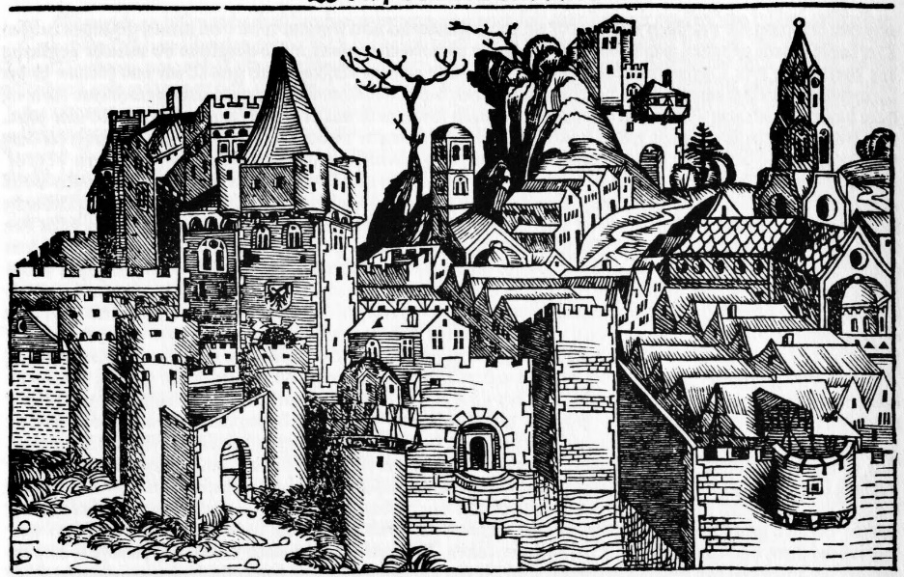
What is a manor?
The manor was the lord’s estate. A manor system was a basic economic arrangement. It rested on a set of rights and obligations between a lord and his serfs. The lord provided the serfs with housing, farmland, and protection from bandits. In return, serfs tended the lord’s lands, cared for his animals, and performed other tasks to maintain the estate.
A manor typically covered only a few square miles of land and usually consisted of the lord’s manor house, a church, and some woodlands. Fifteen to thirty families lived in the village on the manor. Fields, pastures, and woodlands surrounded the village. It was a self-sufficient community because they were able to raise or produce nearly everything that they and their lord needed for daily life.
Assignment:
You will create your own medieval manor map. On page 48 of your Pathways textbook, there is an example of a medieval manor, which you can use as a guide. Please do keep in mind that this is your manor and therefore you should employ creativity and demonstrate individuality. You are welcome to incorporate “fantasy” elements, if you wish.
Finished products:
- A map of the manor land, featuring 12 items (listed on the next page) and a legend. You are welcome to include other elements as well. Make sure that your name your estate and that the name is visible somewhere on the map.
- A brochure or magazine section that features your manor as a charming tourist attraction or focusses on life at your manor during a particular season.

The following items must be included on your map:
- Castle: The dwelling place of the lord and his family and their servants. Castle were built in variety of forms and were usually designed to fit the landscape. Often, castles were built on hills for protection and had moats (water surrounding) and drawbridges to keep enemies out.
- Village church: Site of both religious services and public meetings. A focal point of the property used by all members of the estate.
- Peasant cottages: Peasant homes
- Lord’s demesne (fields owned by the lord but worked by the peasants): In the spring, peasants planted crops such as summer wheat, barley, oats, peas and beans. Crops planted in the fall included winter wheat and rye. Each field was divided into long strips to make sure that everyone had a share of the good land and bad land. The strips were divided by mounds of earth or by rocks. Each year the serf changed the crops they grew in each field, which was called crop rotation. Serfs worked closely together to get all of the work done. Women often helped in the fields.
- Peasants’ crofts: Gardens that belonged to the peasants
- Mill: Water-powered mill for grinding grain
- Common pasture: Common area for grazing animals
- Woodland: Forests provided wood for fuel. The other land around the village was also important. Serfs collected wood from the woodland to build houses or to use as firewood. Hunting for deer, boar (wild pig), and rabbit was also done by bow and arrows. Horses, hounds (dogs specially bred for hunting), and falcons (birds) helped them hunt.
- Meadow: The serf’s animals grazed on the surrounding grassy land, or meadow, and this land provided serfs with nuts, berries, herbs, and mushrooms to supplement their diet and to use for medicine.
- River: Fish could be collected from the river, which was also used for washing and cooking. Waterways were also a source of travel, trade, and protection. Bridges were built to allow transportation across rivers.
- Roads: Roads provided a route for transportation and often led to the nearby village or town. Often people traveled by horse. Medieval streets were narrow and often contained wastewater and garbage.
- Village/town: Roads often led to the village or nearby town where people could visit the market or trade. Some goods found in town were woolen cloths, furs, tin, honey, swords, silks, sugar and spices from Asia.
Additional manor elements: Your choice!
Possibilities include: a falconry, tannery (leather goods), candle-making, pottery, smith, etc.
Below are some websites that may help you plan out your medieval manor design:
http://medievalmanor.tripod.com/manor_full.htm
ftp://heritageacademies.com/ET/CurriculumCenter/NHAHistoryInteractive/Feudalism/manorvirtualtour.html
http://go.hrw.com/hrw.nd/gohrw_rls1/pKeywordResults?ST9%20Medieval%Manor

Medieval Manor Design Rubric:
Category | Points | Possible Points
Design plan: manor looks functional and uses geographic features to great effect. |  | /10
A legend is included |  | /3
Appropriate to the time period/looks like a Medieval Manor. The student has taken care to incorporate medieval design in architecture. |  | /10
Creativity: this manor is not a rip off of textbook sample or other samples viewed in class. |  | /5
Twelve elements are included |  | /12
Brochure is neat, comprehensive and informative. |  | /10
Total: |  | /50

