My Salvation History
Assignment

God acts in our lives to bring us closer to Him. He often sends us people and opportunities to help us become better versions of ourselves.
It is often said that we are the average of five people closest to us. Who are these individuals in our lives? What have they taught you? How have they changed your life for the better? Why are they part of your salvation history?
Brainstorm…
Name of individual | What did they teach you?

Materials:
- Tree picture
- Apple cut-outs
- Pencil crayons
- Scissors
- Glue

Instructions:

A. Written component: (written neatly in ink or typed)
1. Make sure that you include the following formation:

- Title: The People of My Salvation History (TOP, Center)
- Teacher name: Ms. Shin (Top left-hand corner)
- Your name: (Top right-hand corner)
- Class: CE9 (below your name)
- Block: H (below class)

2. Explain how each person has changed your life for the better, teaching you something valuable. You can share an anecdote about how they have introduced a virtue in your life.

Length: 1 paragraph (4-7 sentences for each person).

Please have a subheading for each individual. Make sure it is bold or underlined.

Ex. My Uncle Sam
- (insert information)

B. Art component:

1. List 5-6 individuals who have influenced you (for the better). Write their names down by the roots and draw boxes around their names. Neatly and in ink please. Colour the tree.
2. On the apples, write down the virtue that they have taught you or helped you develop.
Examples:
Love, strength, patience, perseverance, friendship, courage, etc.
3. Colour the apples (make sure that names are visible), cut them out and carefully glue them on the branches of the tree.
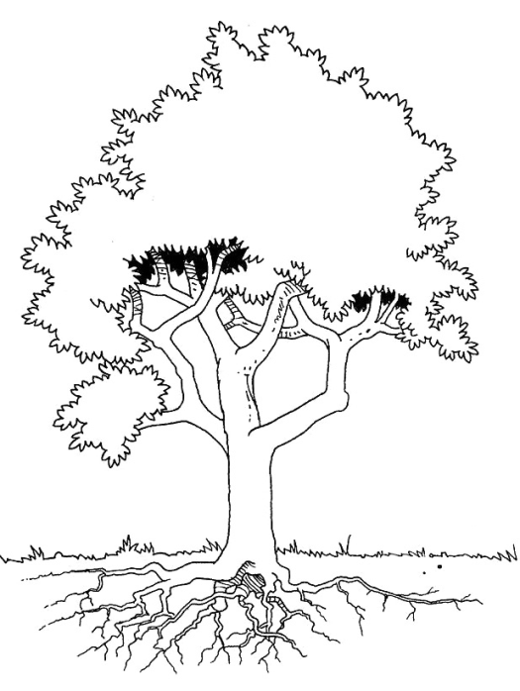
5-6 Names of people who have made our lives better by taking part in it.
Virtues that we have learned from 5-6 people of our salvation history

