The Holy Land: Where Jesus Trod
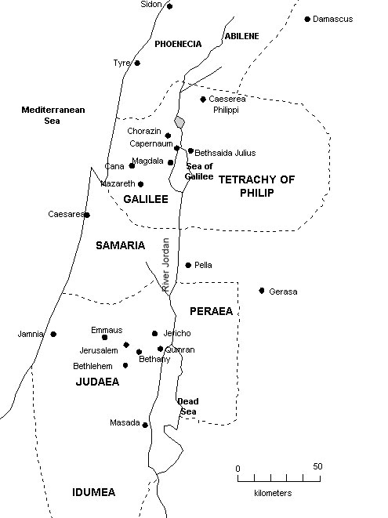
The Provinces: What are some well-known facts about each of these provinces?
Galilee | Samaria | Judea

RECAP of history of the Holy Land before Christ
Significant Old Testament figures mentioned

Interesting observations about OT figures

What is a “Tel”
What do they reveal?

Notable facts about Beersheba

Which “tells” are visited in this documentary? What is the significance of each location?

Describe how Old Testament contracts were made.

Discussion Question:
Compare & contrast OT contracts with modern North American ones.

Church of the Nativity video:
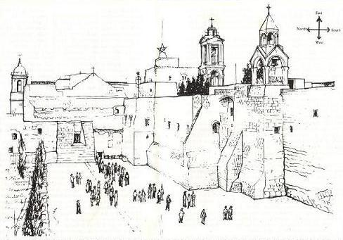
When was it built? Who built it? Why was it built?

What sort of services are held here?
When was the original destroyed?

Who rebuilt the church after its destruction

What did the Ottoman Turks do with the roof?

The main entrance is under the control of which religious group?
Describe the site that is traditionally believed to be the spot where Christ was born.

Nazareth:
Describe the economic conditions of Nazareth during the time of Jesus

Was Joseph able to provide for his family? Explain.

Describe the role of education in Jewish culture

Judea:
- Why was Jerusalem such a significant city for the Jews?

- Why/when did people make pilgrimages there?

- How did Judeans perceive people from other provinces? Any analogies to modern day Vancouver society?

Jerusalem video:
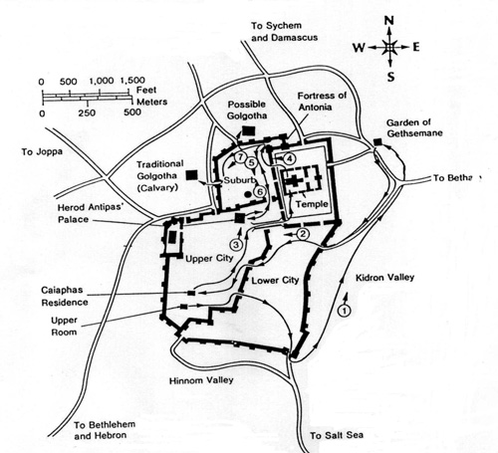
Which Jewish king built the temple?

What mountain is the temple built on?

What other structures are built on the Temple Mount?  (marked by red square) | 1.  2.  3.
It is believed that Christ will enter through this gate at the time of time
What is the significance of the Kidron Valley?

Why was Jesus on the Mount of Olives?
Which garden is located here?

The Western Wall is also known as…
Why is the Church of the Holy Sepulchre a significant site?

What miracle did Jesus perform at the Pool of Bethesda

Galilee:
- What are some notable facts about the Sea of Galilee?

- What are some biblical events that took place at the Jordan River?

The Oppressors of Jesus’ People:

- Who were they?

- Who was their puppet native ruler?

